# WEB CHAT REAL-TIME APPLICATION

### **Introduction**

With the advent of improvements in technology nowadays web applications are used on a large scale. One of such applications which are most frequently used is web chat applications. The main goal for the project revolves around developing a web chat application applying the design thinking principles that I learn as part of my course technical interaction design at IT university of copenhagen. The implementation part of the application will make use of markup language HTML, CSS styling, and client-side programming languages using JavaScript react libraries. Although, the context to whom the project will be applicable will be explained by focusing on the users I choose. To understand this, firstly I will be defining the user group and then select a target group among the user group. The user group's needs and expectations can be derived by performing empathy research. Further details on what methodology I choose to undergo empathy research and the reason how it can benefit our project will be furtherly explained in the respective sections below.

**User group and target group:**

Understanding the use context is important as the success of the software highly depends on how well it fits its environment and the use context (Parnas, 1999). As I build the project on the chat application the focus will be to provide a channel with a user interface experience where the users can communicate with each other and respond or react to the messages whenever necessary in real-time.

Firstly, after doing a brainstorming session to pick the user group, I agreed with students at the university. Since there are multiple social media platforms where most students prefer to communicate yet there has not been a common platform where a maximum number of students would be interested and that will be our primary reason for choosing students as our user group will be dependent on these criteria.

Secondly, I proceeded to do a bit more detailed research about the idea of the project, and the user group and then we selected the target group for the project, who are the guest students at the university. The requirements from the target people are described in the next section which it deals with empathy research.**na)**

### **Empathy research: choosing interview & 5 why’s methods**

We conducted research combining two methods: I conducted unstructured interviews using the 5 Whys method. Each group member conducted one or two interviews with empathy. The interviewees are from different universities in Denmark (CBS, DTU, ITU, and KU), and they are friends or classmates of group members. Each interview lasted 10-20 minutes and all the questions were related to the experience of research projects with some specifically focused on the recruitment process.

### **Why I Did It**

We conducted the research using the 5 Whys method because I considered it the most appropriate to get to the core of the problem. The method helped us understand that finding why students feel as a challenge for communicating among other students. At the same time, I did an unstructured interview because I wanted to explore other aspects related to know the pain points of the target user to create a platform where they more committed.

Most of the other empathy methods are not feasible for us to use at this stage. For example, many methods are based on user observation. On one hand, our potential users don’t really have one fixed way to recruit their participants, nor have I a prototype for them to try out. On the other hand, the process of recruitment often takes a long period of time which creates more difficulty for us to observe.

To summarize, through the methods I used I wanted to understand if there really is a need to create a live chat that will help guest students at the university to get to know better well in advance to form groups.

### **Reflections**

**Insights**

The most common channels for guest students to communicate between them before they get into a course are Facebook, school (forum, classmate, bulletin board, excel etc.), and topic-specific online forums, but there are many factors influencing whether potential participants will respond or not, such as the design of the questionnaire and the time requirement. Meanwhile, the help from the supervisor regarding participant recruitment is very limited. Most of our interviewees believe that compensation or reward could be offered as extra incentives for people to get involved in the research, but as students, their resources are very limited. Therefore, I would like to conclude that the **root cause** of the difficulty in finding participants: people don’t have enough incentives.

In addition, students encounter difficulties in finding master thesis companies. Since the process of finding a partner company is not common, students lack the knowledge and workflows for finding interested parties.

**Interview Skills**

The unstructured interview with both focuses on general difficulties in research projects and the recruitment process in detail was very challenging and the interviewees could be confused without a thorough explanation beforehand. One-on-one interview without a moderator was also demanding, especially when there could be three or four possible follow-up questions after one answer from the interviewee.

It is both challenging and insightful in how many ways an interview can go. Each time I started off with the same questions, but the final conclusion was rarely the same. This pushes us to take an open stance any time I build something for general use - there are as many preferences as there are people.

### **Defining problem domain- Methodology**

To support the user’s needs and expectations, I used different methods to define the problem domain i.e., personas as it creates a fictional character based on the empathy research. Then I extended the problem statement (POV) by expressing the definitions and creating a POV mad lib to support the ideation phase.

#### **Personas**

Personas makes the design task less complex and help the development team to create a good user experience for the target group (Dam & Siang, 2020). We choose the engaged personas because they could make use of the information from our empathy research, allow us to construct one persona from our target group. It is also possible to create scenarios using this method (Bjorn, engaging persona.pdf).

After collecting the user data based on the empathy research, I wanted to develop a rough understanding about the differences among target group users.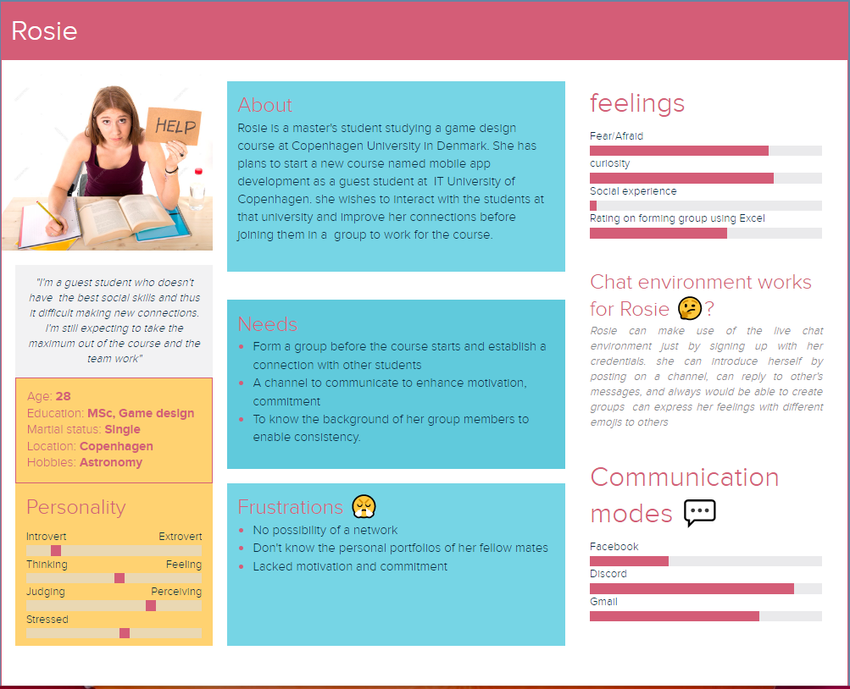

**Defining Problem statement - Point of view**

Based on our problem statement, I use the point of view (POV) to fill the gaps between users’ problem and their goals/needs.

|  |  |  |
| --- | --- | --- |
| User | Need | Insight |
| A guest student who is about to take a course at a Danish university | Wants to know the working style and educational background of other students to find best fitting team members in order to excel in the course as the course demands working in groups | * International students with low social skills are having a hard time making new connections without the help from faculty members. * It’s particularly difficult for students who do not have any friends taking the same course. * Socializing with classmates would help to find the best fitting group members |

**POV madlib:**

A guest student who is about to take a course at a Danish university needs to know about the educational background of their fellow students to find group members she would work well together. This would ease the socializing process for introverted students and make them more independent.

**Ideation – How might we?**

We have described our design challenge in the POV. Now, I will use the How might we? technique to explore the range of possible solutions. We eventually choose the best fitting solution. The technique for the above POV is given below.

How might we:

1. How might we help students to know about other students working styles and commitment?
2. How might we get students to interact with others?
3. How might we help students to find the best fitting group members?
4. How might we help students to form friendships in a new setting?
5. How might we encourage introverted students to connect with future fellow students?

**Results**

We discovered that international students and students with low social skills are the most in a need of a forum to connect and socialize. Extroverted people tend to prefer connecting to people in the classroom and being proactive. However, they still see value in knowledge sharing and keeping up to date with general announcements. Nevertheless, I should focus our efforts on the users who are most vulnerable. For example, the ones who do not have any friends taking the same elective course.

**Reflections**

We have conducted empathy research by interviewing 3 guest students. Ideally, I would like to interview additional students who would have more introverted personalities. It was challenging to create a generalized persona when our sample size is very limited. To get a better understanding of the general guest student, I would need a larger sample size and a more diverse set of guest students.

Regarding learning new concepts, the PoV mad lib was helpful to structure our ideas. Throughout the interviews, I discovered that our user group is more narrow than expected. Going forward, I will be focusing on particularly fulfilling their needs.

Regarding improvements, I would need larger and more diverse data to ensure that our persona is valid if I have more time and resources. We would recruit with more specific characteristics (e.g. introverted students) to expand our understanding of their needs and better emphasize with them.